
E-Commerce & Digital Marketing
( Course Code: CSC417 )

Name: Muhammad Abdullah
Roll No # FA24-BSE-042
Class: BCS-4B-SP26
Instructor Name: Sir Omer Vikas

LAB - Final
Q1: Create an online store for your brand
Brand Name: GaliMart
Niche: Hyperlocal Marketplace & Community Commerce Platform
I designed and developed an online marketplace platform called GaliMart that focuses on connecting local buyers and sellers within nearby communities. The platform provides users with a modern and responsive shopping experience where they can browse products, explore categories, and purchase items from local vendors.
The store interface includes product listings, product detail pages, shopping cart functionality, responsive design, and a clean user interface optimized for both desktop and mobile users.
The main goal of GaliMart is to simplify local shopping and support small businesses by creating a digital marketplace for neighborhood commerce.
Output: Store Pages
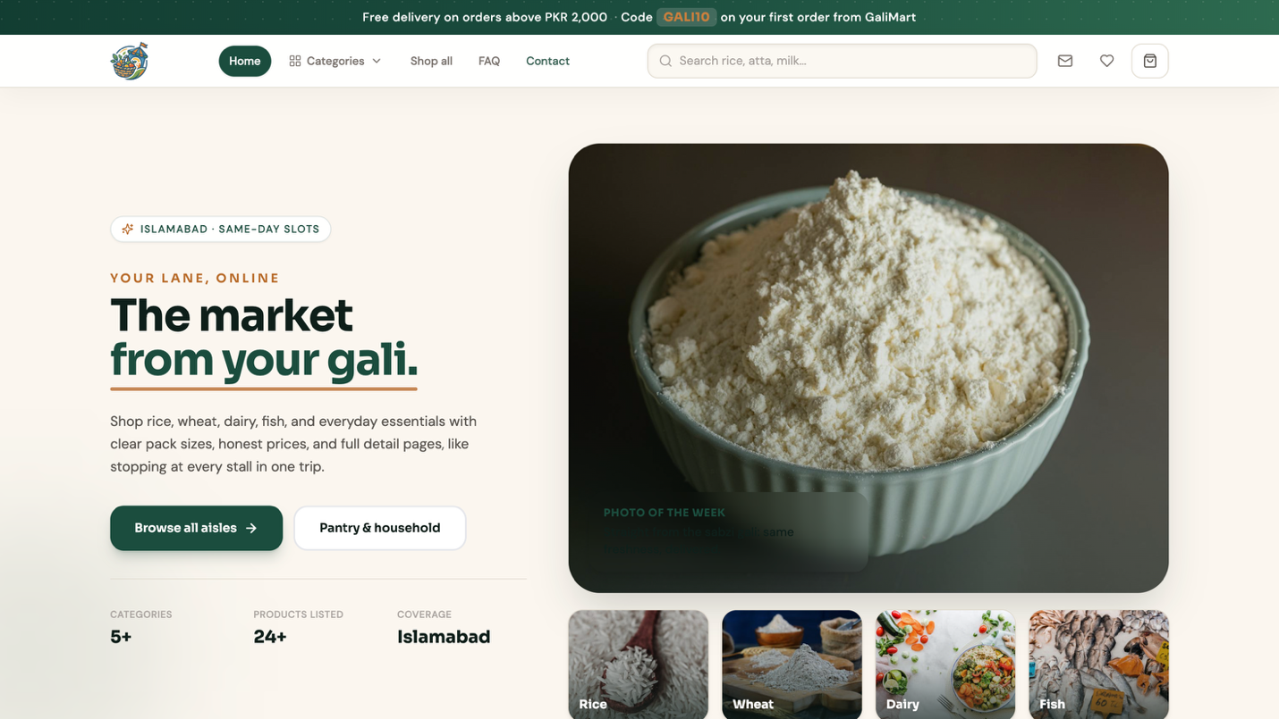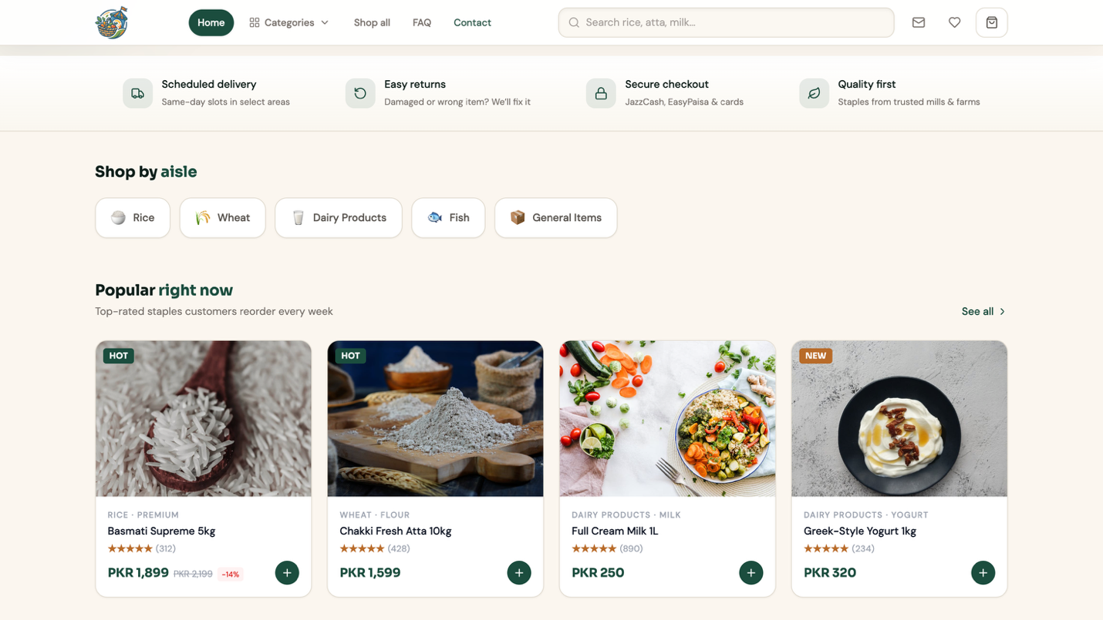
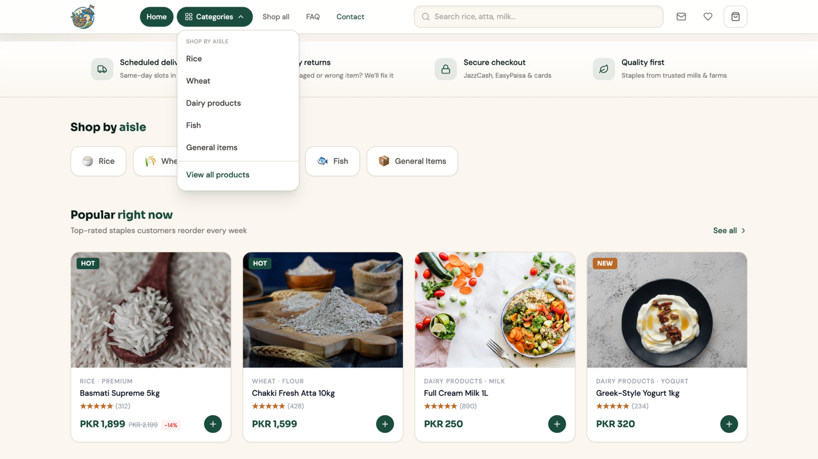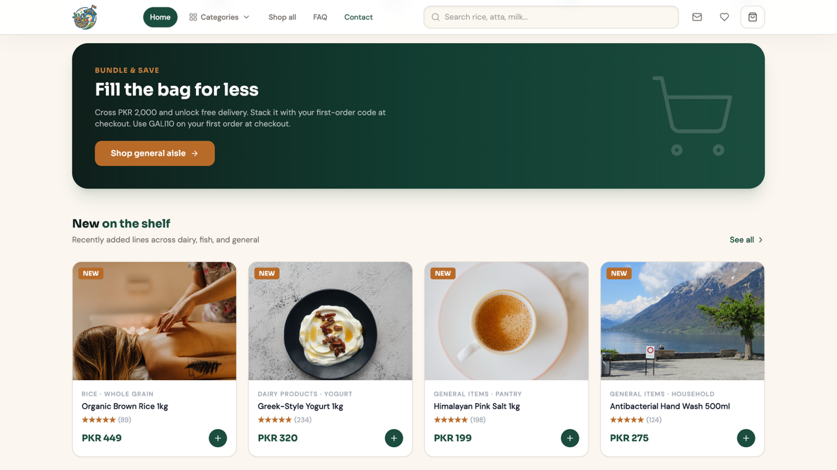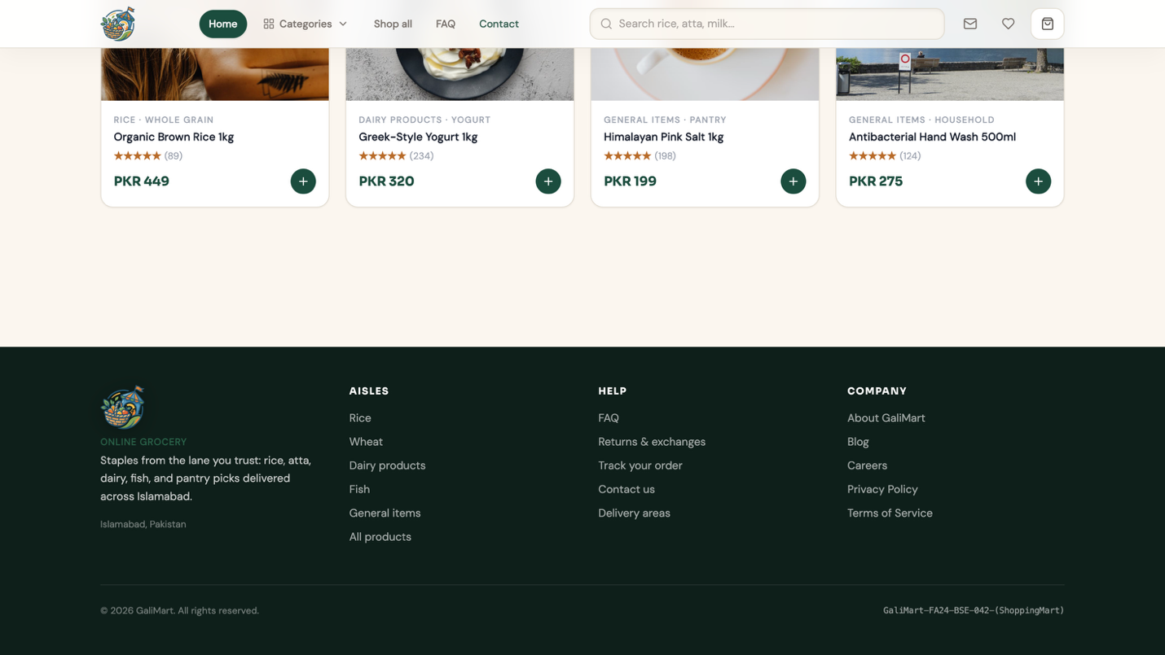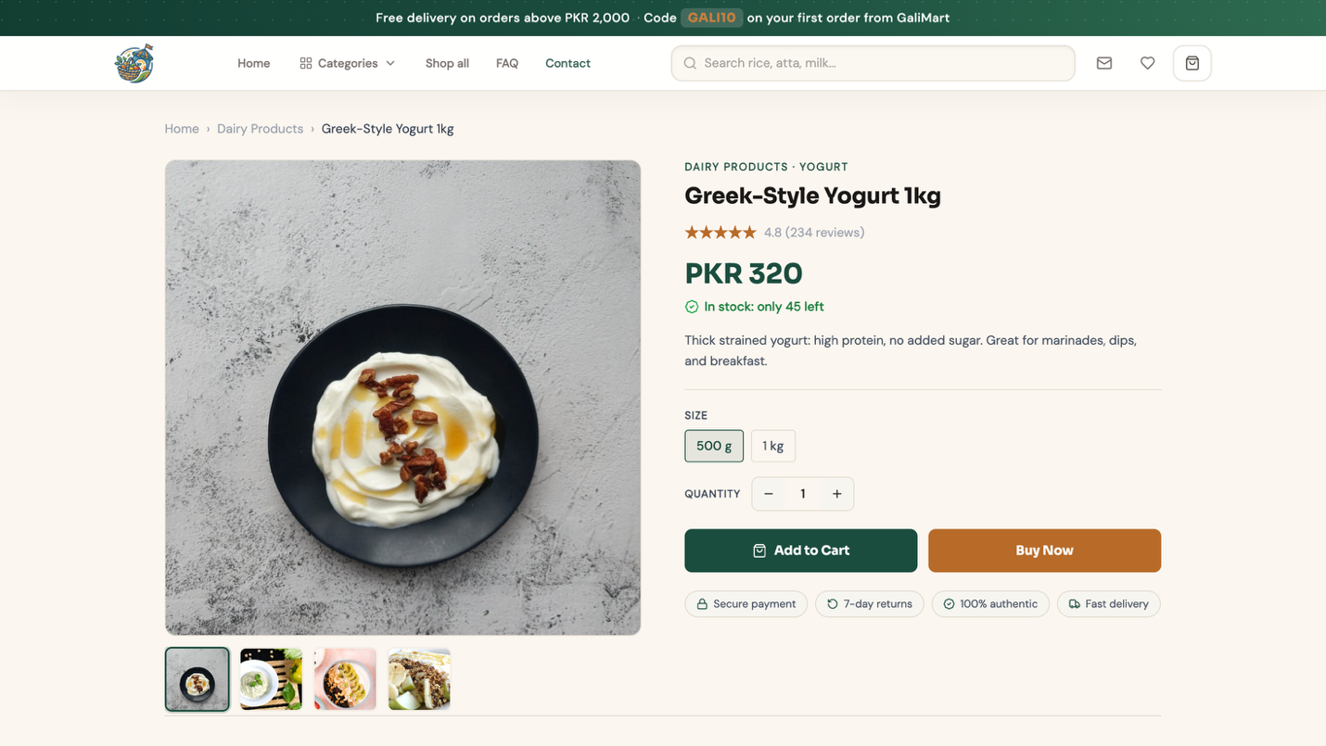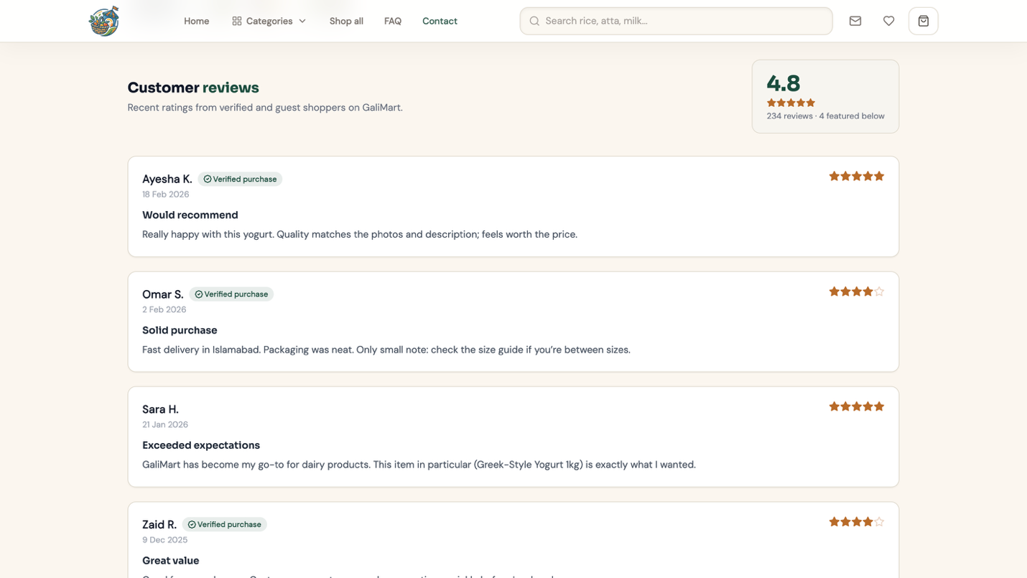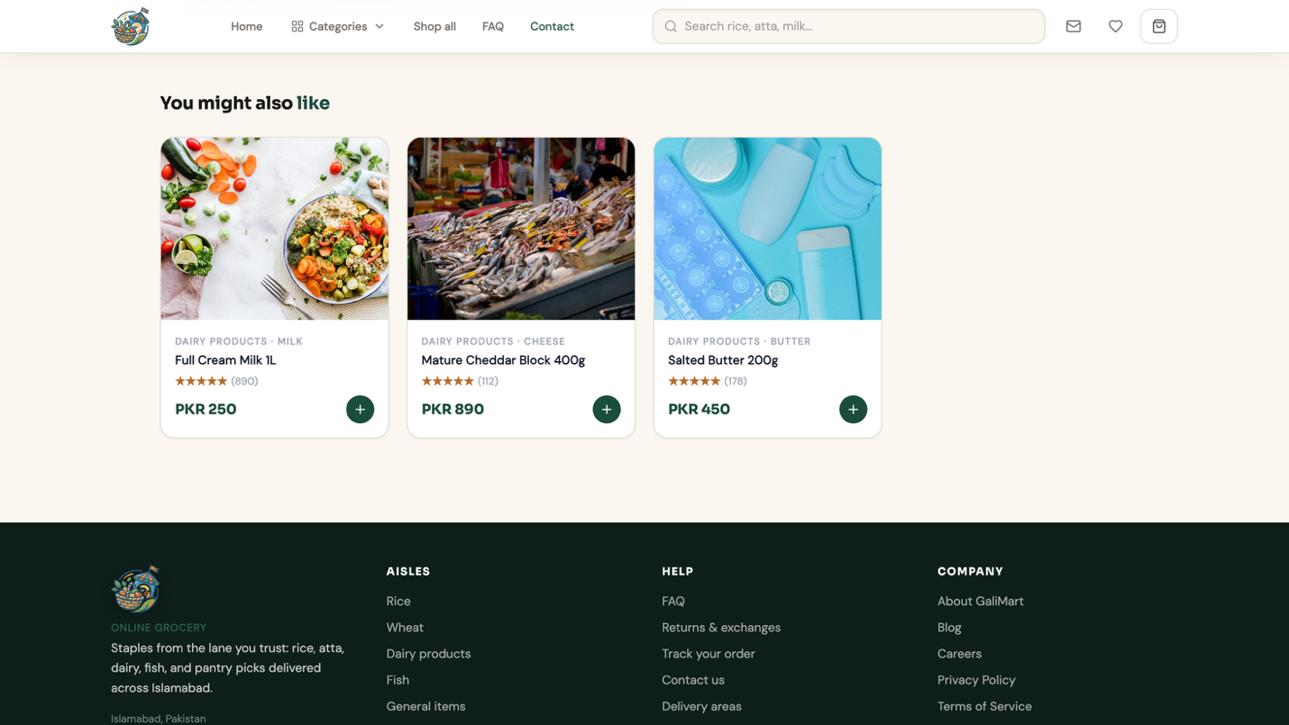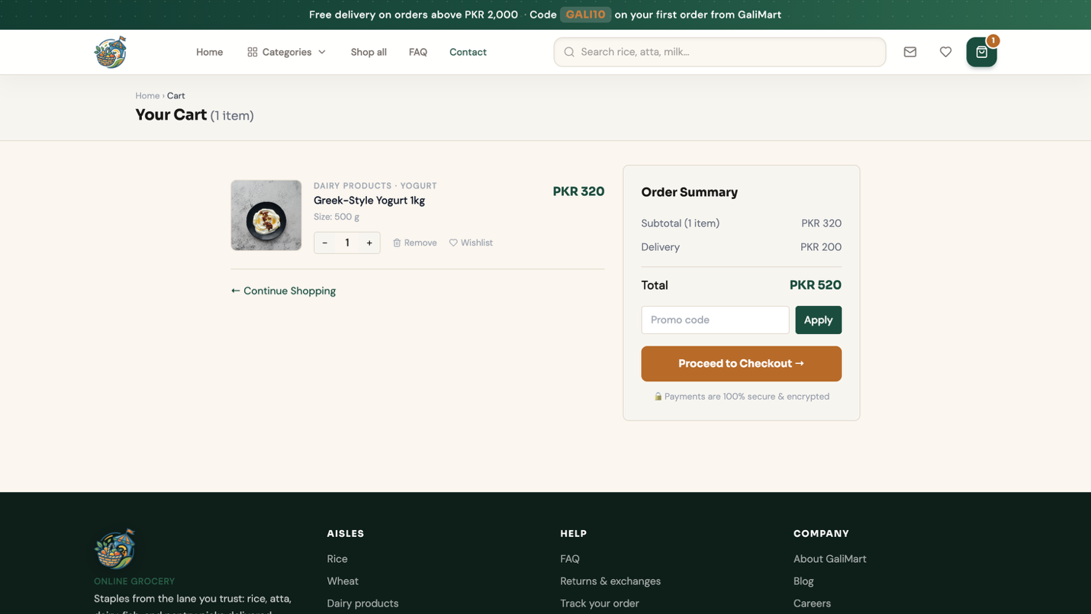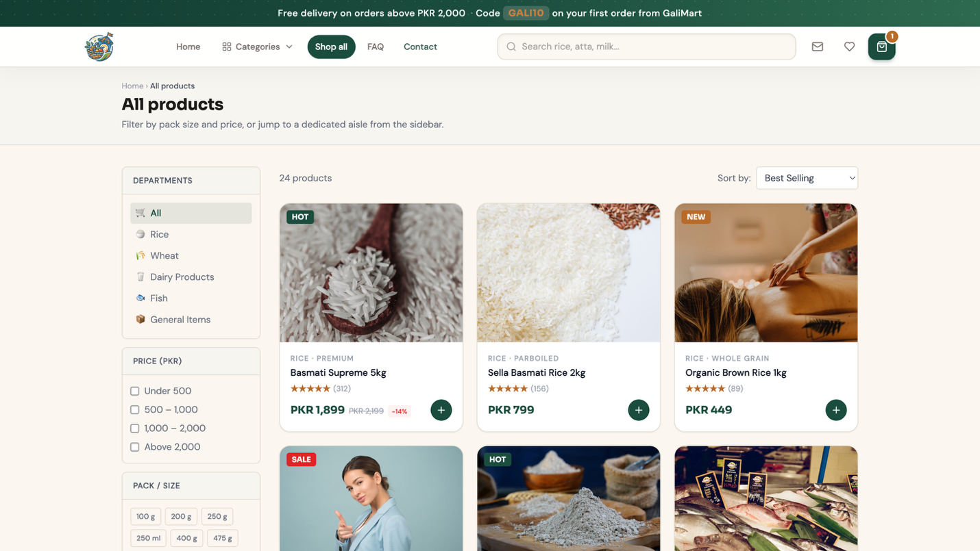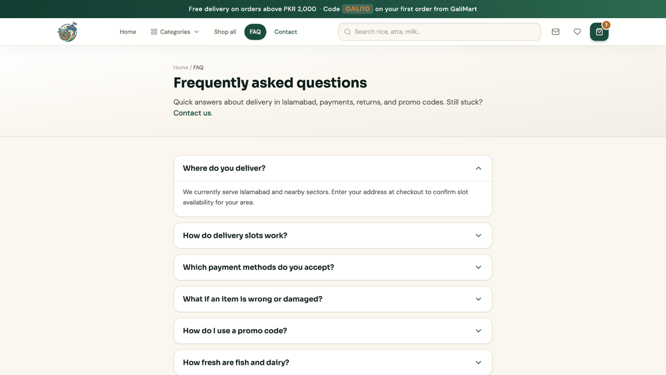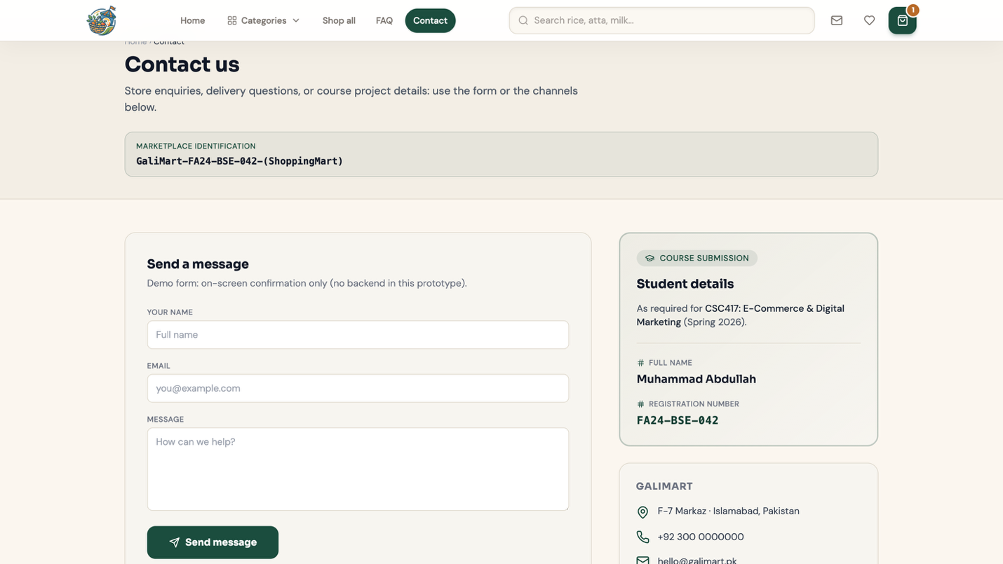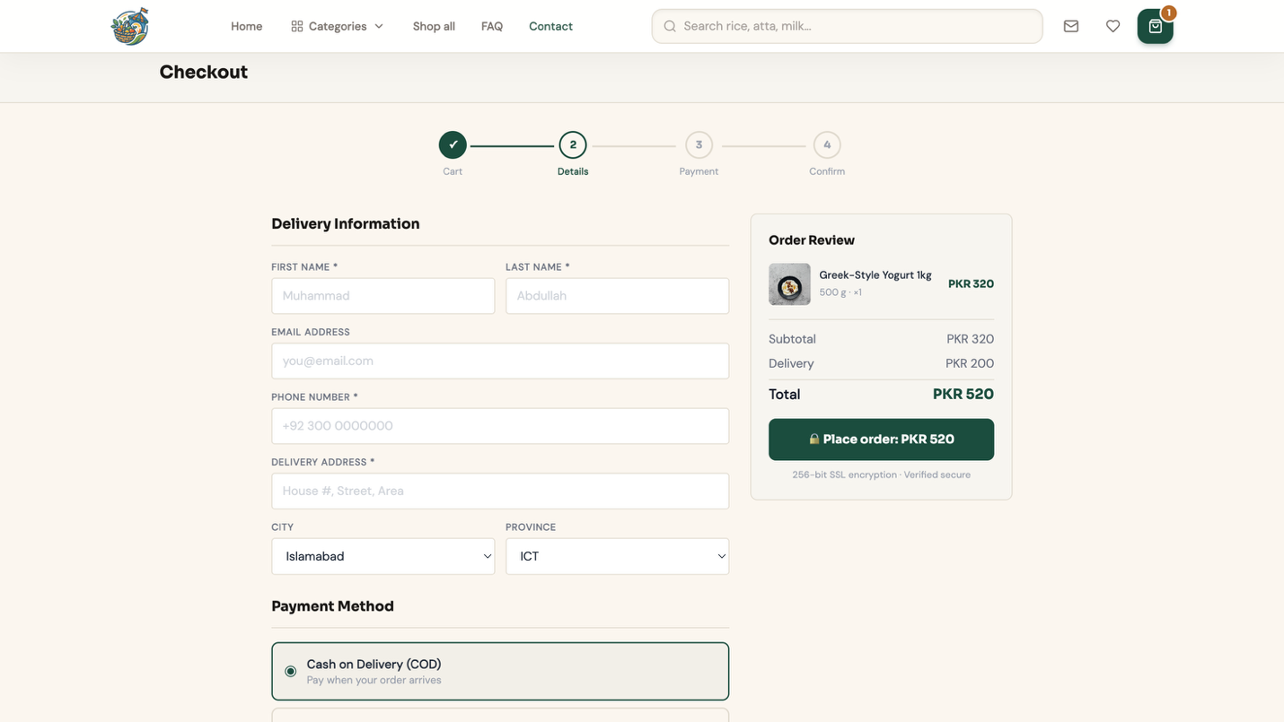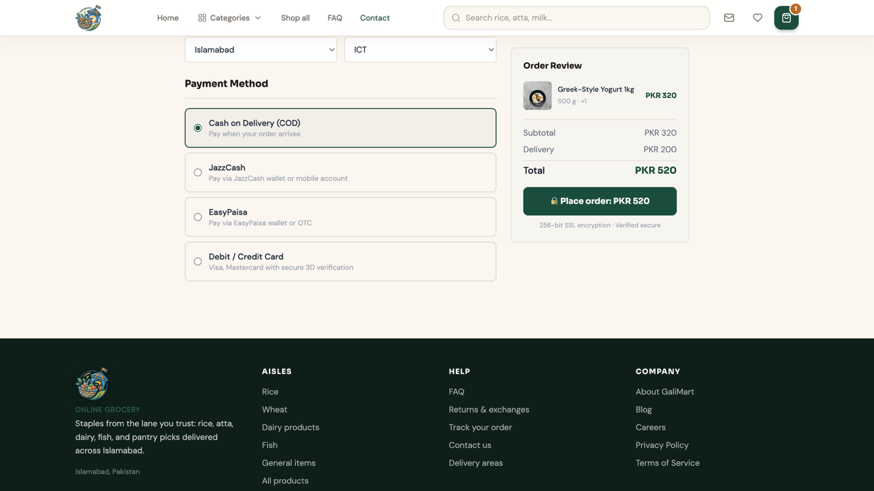

Q2: Brand Color Theme & Logo Design
For GaliMart, I selected a color theme that reflects trust, community, growth, and reliability. The combination of earthy orange and deep green creates a natural, friendly, and community-driven marketplace feel that aligns perfectly with the brand vision of “Your Gali, Your Market.”
The selected palette was carefully chosen to represent local commerce, neighborhood connection, freshness, and accessibility while maintaining a clean and modern digital appearance.
Palette:
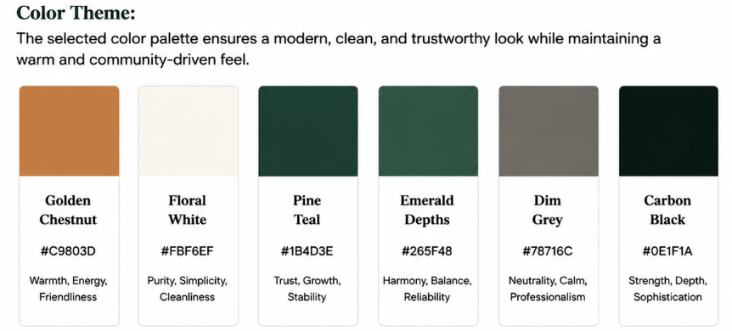
Color Name | Hex Code | Purpose
Golden Chestnut | #C9803D | Represents warmth, energy, and friendliness
Floral White | #FBF6EF | Represents simplicity, cleanliness, and minimal design
Pine Teal | #1B4D3E | Represents trust, stability, and professionalism
Emerald Depths | #265F48 | Represents growth, harmony, and reliability
Dim Grey | #78716C | Represents balance, neutrality, and modern UI structure
Carbon Black | #0E1F1A | Represents depth, strength, and premium visual contrast

Logo:
I designed a custom logo that visually represents a local community marketplace. The logo combines elements of a traditional market stall, fresh produce, and natural leaves to symbolize local shopping, freshness, sustainability, and trusted neighborhood commerce.
The circular composition of the logo represents unity, connection, and continuous community interaction between buyers and sellers. The flag element reflects local identity and gives the logo a recognizable marketplace character. The overall design creates a modern yet friendly visual identity that is suitable for digital platforms, mobile applications, social media, and e-commerce branding.

Brand Tagline:
“Your Gali, Your Market.”
Q3: SMART Goals & Customer Persona
SMART Goals
- Specific: Increase local marketplace engagement by reaching 1,000 monthly active users and onboarding at least 50 local sellers on the GaliMart platform.
- Measurable: Performance will be tracked using website analytics, user registrations, product listings, and customer engagement metrics.
- Achievable: The goal can be achieved through consistent social media marketing, local promotional campaigns, SEO optimization, and community-focused digital outreach.
- Relevant: These goals are essential for establishing GaliMart as a trusted hyperlocal marketplace that supports nearby buyers and local businesses.
- Time-bound: The target is to achieve these milestones within the first 6 months after the platform launch.
Customer Persona: “The Smart Local Shopper”
Category | Details
Age | 18 – 35 years old
Interests | Online shopping, local businesses, fast delivery, technology, convenience
Shopping Behavior | Prefers mobile-friendly platforms, compares prices before purchasing, values fast delivery and trusted sellers
Goals | To purchase affordable and reliable products from nearby sellers quickly and conveniently
Barriers | Concerns about product quality, delivery reliability, online payment trust, and fake sellers

Persona Explanation:
The primary target audience of GaliMart consists of digitally active local shoppers who prefer convenience and quick access to nearby products. These customers value trusted local sellers, affordable pricing, and a smooth online shopping experience.
GaliMart aims to solve common problems faced in local shopping by providing a centralized marketplace where buyers can easily discover products from nearby vendors while supporting local businesses and community commerce.

Q4: SEO Research & Keywords
To improve the visibility of GaliMart in search engines, I researched trending and low-competition keywords related to local e-commerce and hyperlocal marketplaces in Pakistan. These keywords can help attract users searching for nearby shopping platforms, grocery delivery services, and trusted local sellers.

# | Keyword | Competition (SD) | Trend | Search Intent
1 | Local online shopping Pakistan | Low | Rising | Commercial
2 | Online marketplace Pakistan | Medium | High | Commercial
3 | Grocery delivery Islamabad | Low | Rising | Commercial
4 | Local shopping app Pakistan | Low | Rising | Informational
5 | Hyperlocal marketplace Pakistan | Low | New | Commercial
6 | Buy local products online | Medium | Stable | Transactional
7 | Electronics delivery Islamabad | Medium | Rising | Transactional
8 | Community marketplace Pakistan | Low | Stable | Informational
9 | Local sellers marketplace | Low | Rising | Commercial
10 | Online grocery store Pakistan | Medium | High | Transactional

Keyword Strategy Analysis
The SEO strategy for GaliMart focuses on targeting localized and low-competition keywords related to online shopping and hyperlocal commerce in Pakistan. The primary objective is to rank for search terms that users commonly search when looking for nearby sellers, grocery delivery services, and trusted local marketplaces.
Based on keyword research data from Ubersuggest, keywords such as “Local online shopping Pakistan” and “Hyperlocal marketplace Pakistan” show growing search trends with relatively low SEO competition. This creates a strong opportunity for GaliMart to gain organic traffic without competing directly against large international marketplaces.
The platform will also target informational keywords through blogs and category pages to attract users during the product discovery phase and guide them toward transactional product listings. By focusing on localized search intent and community-driven commerce, GaliMart can build a stronger regional online presence and improve search engine visibility.
Output Screenshot: Keyword Analysis:
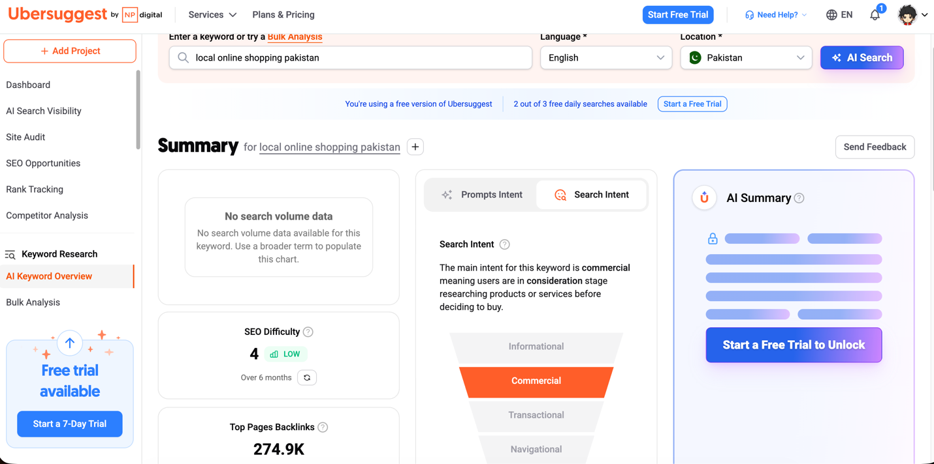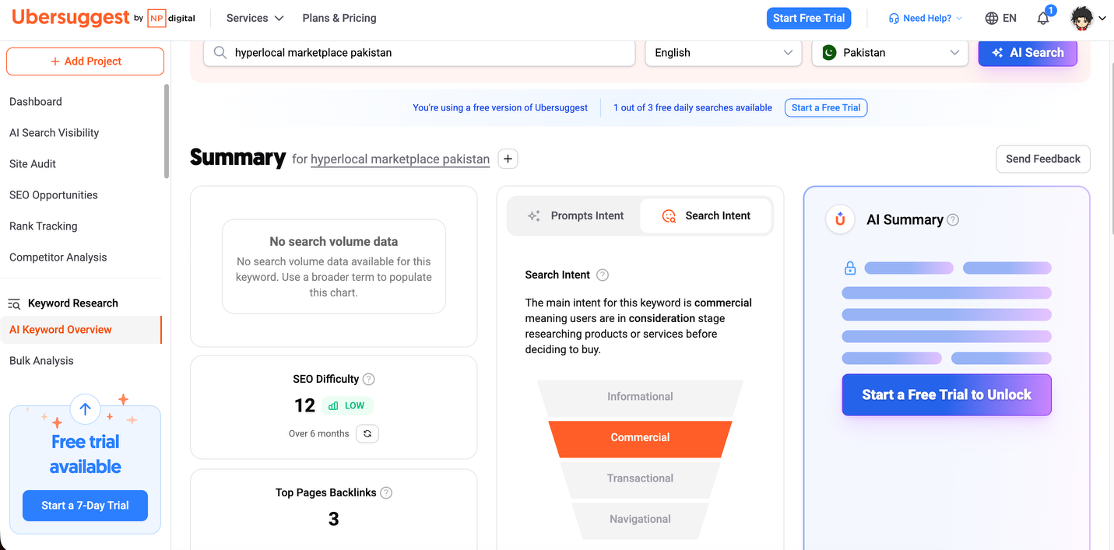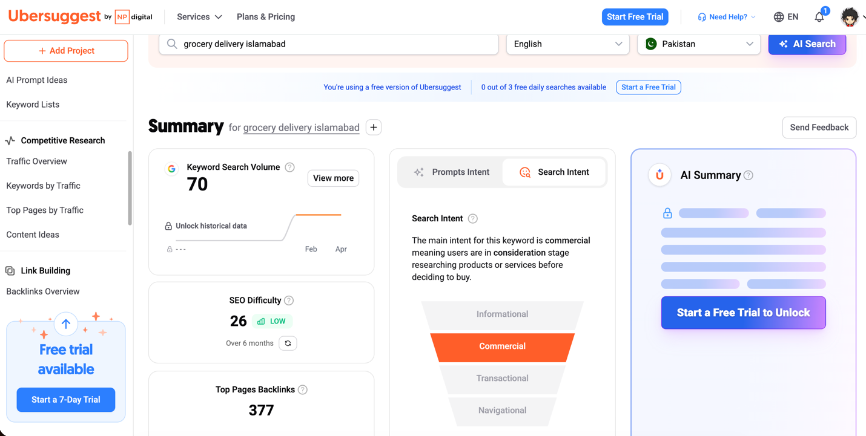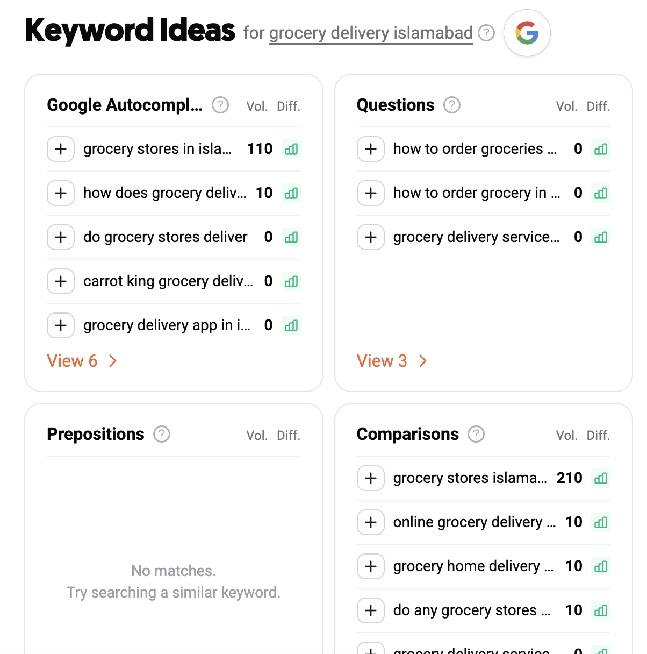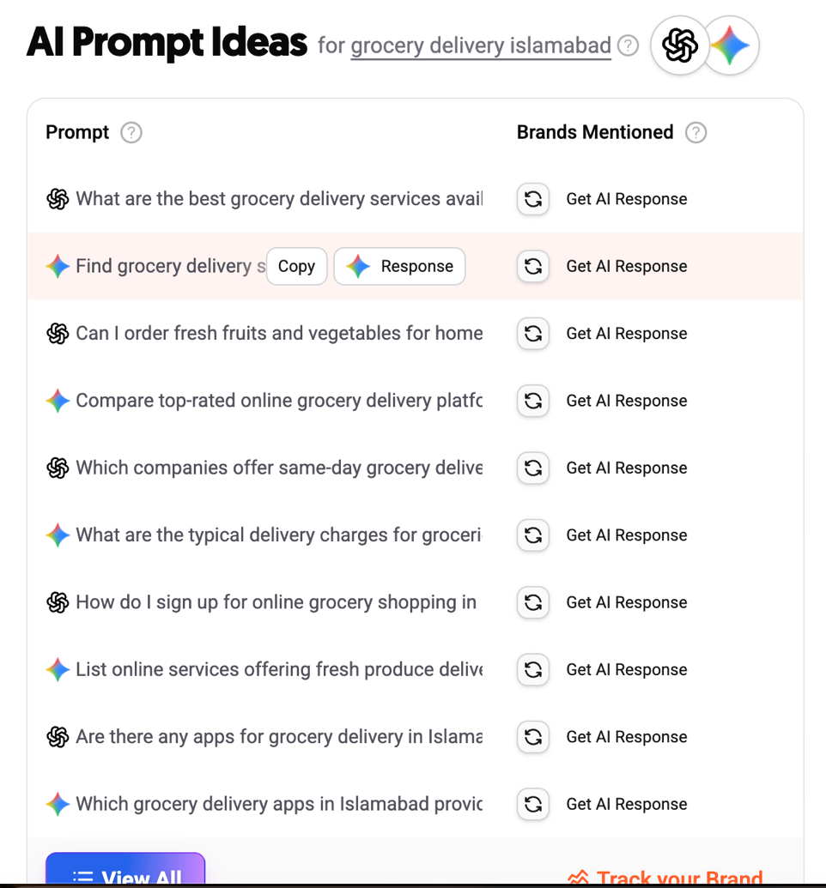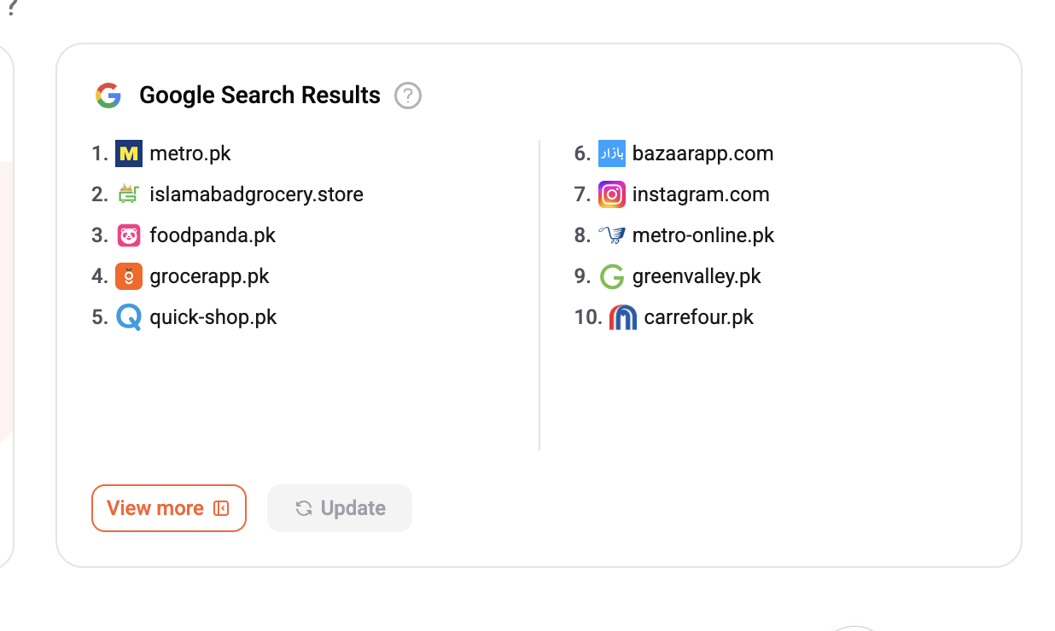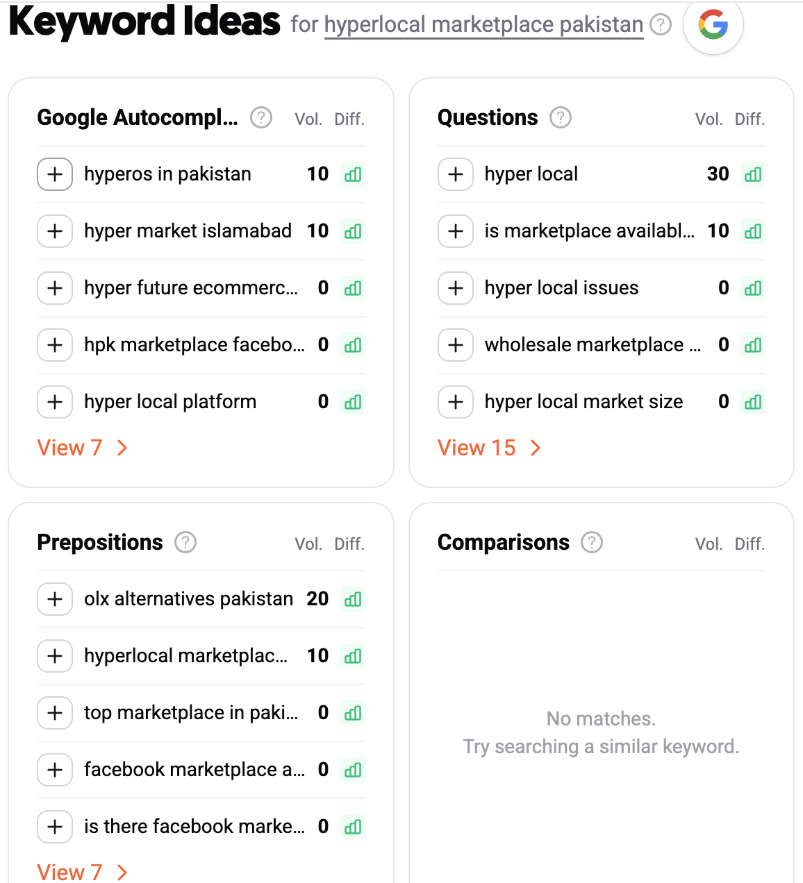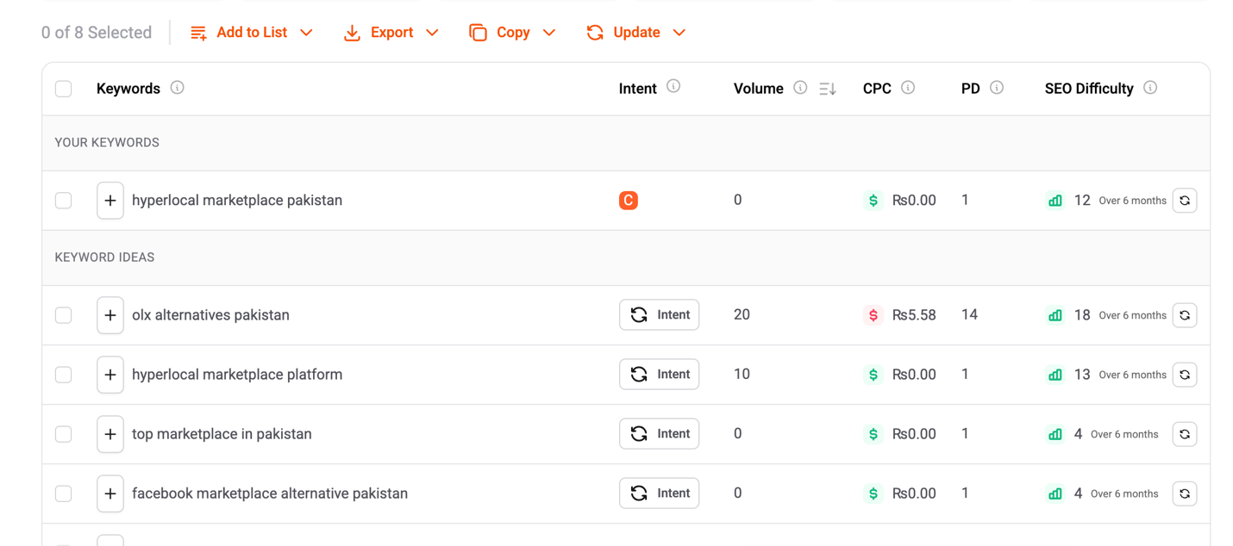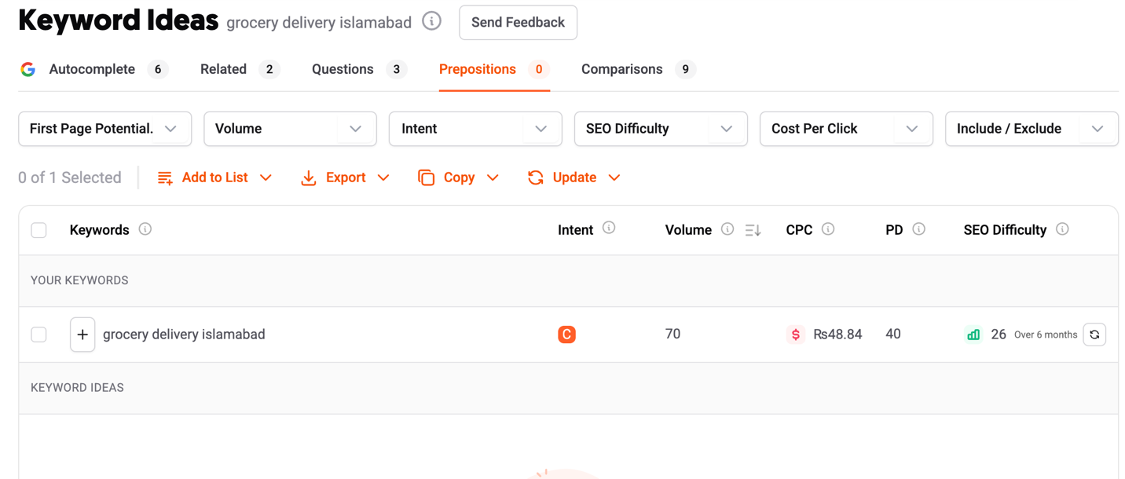

Q5: Marketing Strategy & Email Design
(a) Selected Marketing Type
Chosen Method:
Social Media & Community Marketing
Justification:
GaliMart is a community-driven hyperlocal marketplace platform, making social media marketing one of the most effective methods for audience engagement and brand growth. Platforms such as Instagram, Facebook, and TikTok allow GaliMart to promote local sellers, showcase trending products, and build trust within nearby communities.
By creating engaging short-form content, local promotions, and community-based campaigns, GaliMart can attract both buyers and sellers while increasing brand visibility. Social proof through customer reviews, local vendor collaborations, and community engagement helps establish trust and encourages more users to shop through the platform.
In addition, location-based marketing campaigns can help GaliMart target users within specific cities and neighborhoods, making the marketing strategy highly relevant and cost-effective.

(b) Email Marketing Design
I designed a professional email marketing template that follows GaliMart’s brand identity and visual theme. The email design uses the brand’s earthy orange, deep green, and minimal neutral color palette to maintain a modern and trustworthy appearance.
The email includes:
- Personalized customer greeting
- Featured products and marketplace highlights
- Promotional offers and discounts
- A clear “Shop Now” call-to-action button
- Social media and contact links
- Responsive mobile-friendly layout
The purpose of the email campaign is to increase customer engagement, promote local sellers, and encourage repeat purchases through targeted digital marketing communication.
OUTPUT: Screenshots of Email
